TB INCIDENCE

91 000

FELL ILL WITH TB
(55 000 - 136 000)

74 799
people with TB notified (new and relapse)

16 000
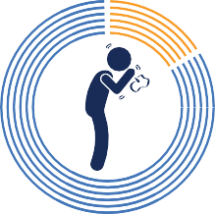
people not notified or not diagnosed

TB INCIDENCE 2000-2021

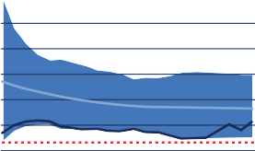
450

375

300

225

Incidence

62% 24% 14%
MEN WOMEN CHILDREN
150

75
Rate per 100 000 population

0
Year: 2000 - 2021
Notification
2025 End TB
Milestone

TB MORTALITY

12 000

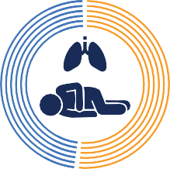
including

TB MORTALITY 2000-2021
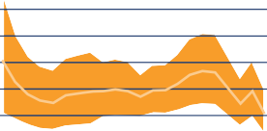
(EXCLUDES PEOPLE WITH HIV)

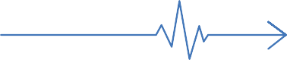
TB DEATHS
(8 700 - 17 000)

DIAGNOSIS

6 200 
DEATHS AMONG
people with HIV
37 500

31 250
Number of deaths

25 000

18 750

12 500

6 250

0

Year: 2000 - 2021

Mortality
2025 End TB
Milestone

USE OF WHO-RECOMMENDED RAPID DIAGNOSTICS

69%
People newly diagnosed with TB using WHO-recommended rapid diagnostics

TREATMENT
TB TREATMENT COVERAGE
PEOPLE DIAGNOSED WITH DRUG-RESISTANT TB

506
Laboratory-confirmed with rifampicin resistance among
1 500 people who fell ill with drug-resistant TB

DRUG-RESISTANT TB
TB TEST FOR PEOPLE LIVING WITH HIV

23 692
notified among 29 000 people living with HIV

TB/HIV

82% 

Treatment success rate 85%
90%
2025
End TB target

1 500
(450 - 2 500)
people fell ill with drug-resistant TB
506

342
people started on second-line treatment

people started on WHO-recommended shorter treatment regimens

29 000
(17 000 - 44 000)
people living with HIV fell ill with TB

23 674
people notified and put on antiretroviral treatment


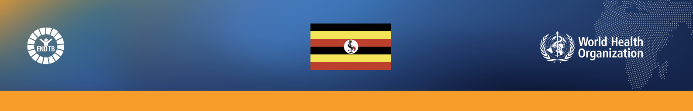

UGANDA
46
Population:
million
2021
WHO GLOBAL TB REPORT 2022 | COUNTRY PROFILE
16 833 13 409 8 692
HIV-positive people Children (aged <5 People (aged ≥5 (newly enrolled years) household years) household in care) on TB contacts of contacts of preventive treatment bacteriologically- bacteriologically-
confirmed TB cases confirmed TB cases
on TB preventive on TB preventive
treatment treatment
53%
TB patients facing
catastrophic total costs
Year of survey: 2017
50
40
30
20
10
0
US$ 47M
NATIONAL TB BUDGET

Unfunded
Funded internationally Funded domestically
Year 2022
TB-SDG MONITORING FRAMEWORK
TB PREVENTIVE TREATMENT TB CATASTROPHIC COSTS TB FINANCING 2022
US$ millions


NUMBER OF TB CASES ATTRIBUTABLE TO 5 RISK FACTORS
Population living below the international poverty line (% of population)
Household health expenditure
>10% of total expenditure/income (% of population)
UHC index of essential service coverage (%)
Population covered by social protection systems (% of population)
41%
15%
50%
1.2%
Monitoring of the above indicators can be used to identify key influences on the TB epidemic at national level and inform the multisectoral actions required to end TB.
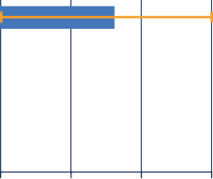
HIV
Diabetes Smoking Undernourishment Alcohol use disorder
0 20 40 60
Thousands

